Queensland University of Technology

Brisbane Park Search

Test Plan Report

Riccardo Grinover – N8783012

Reef James Stevens - N9441409

*Website to be tested in CHROME*



# Accessing the home screen

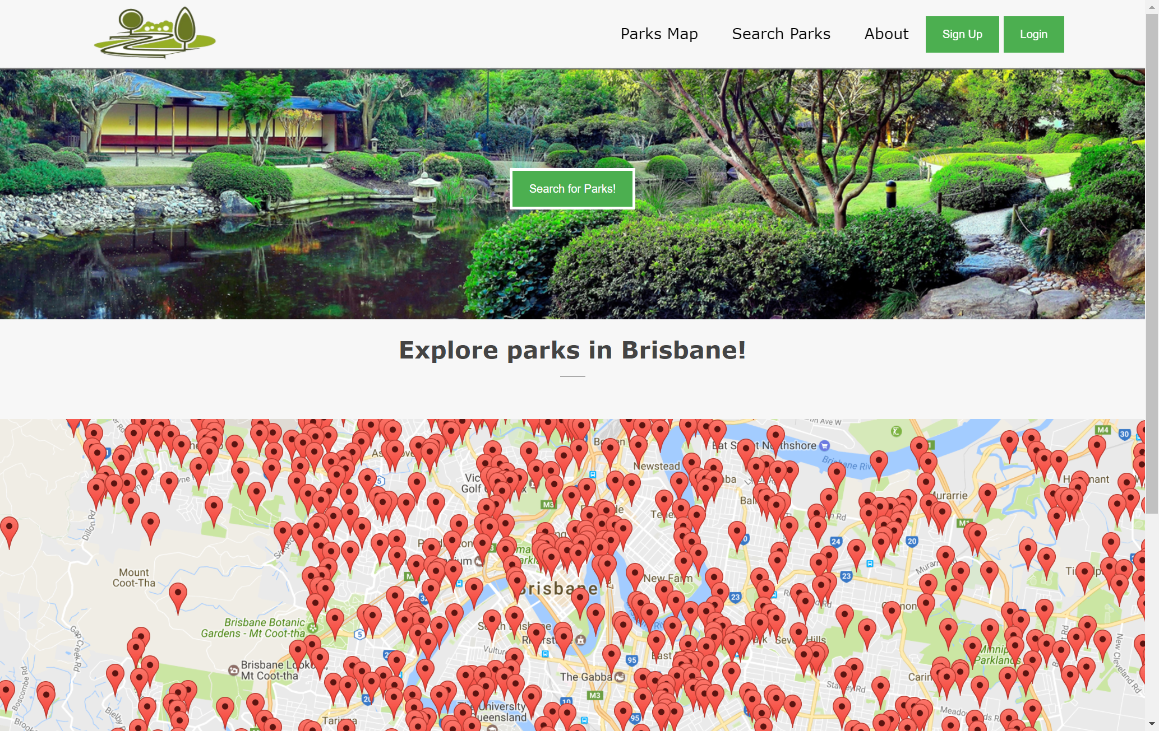

## Header



The ***header*** of the website is *common* across all webpages in the website. It contains a generic park *logo*, a “*Nearby Parks”* clickable option that directs you to a div on the homepage that contains a map showing all of the parks around Brisbane. A clickable option that directs you to a search page as well as an option that directs you to an “*about us”* page.

There are two key buttons location in the header:

* *Sign up* – This button, when clicked directs you to a sign-up form.
* *Login* – This button directs you to a login form that allows you to input your login information, if you have made an account. Note, if the user is already logged in, the “*login”* button will be replaced with a “*logout”* button. This will be shown later in the report.

## Body

The body consists of a search button that navigates the user to the search page, similar to the “*Search Parks”* option in the header. The remaining section of the body consists of a “explore the parts of Brisbane” section that shows all the parks from the provided dataset on a map, using the Google Maps Api.

## Footer



The footer shows some contact details, “our mission” and why the website has been created. Like the header, the footer is common across all webpages in the website.

# Registering as a new user

## No INPUT - Have not clicked sign up

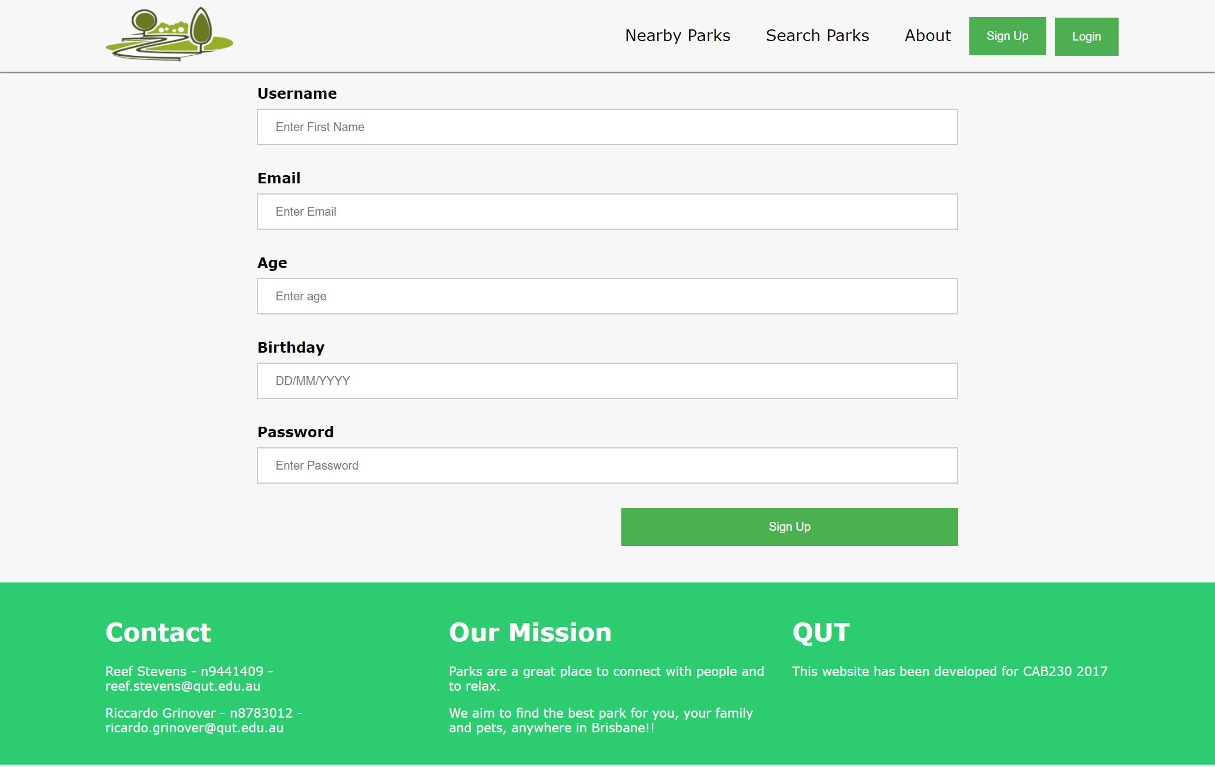

No warnings display, as the user has not yet submitted the form.

## No input – Have clicked sign up

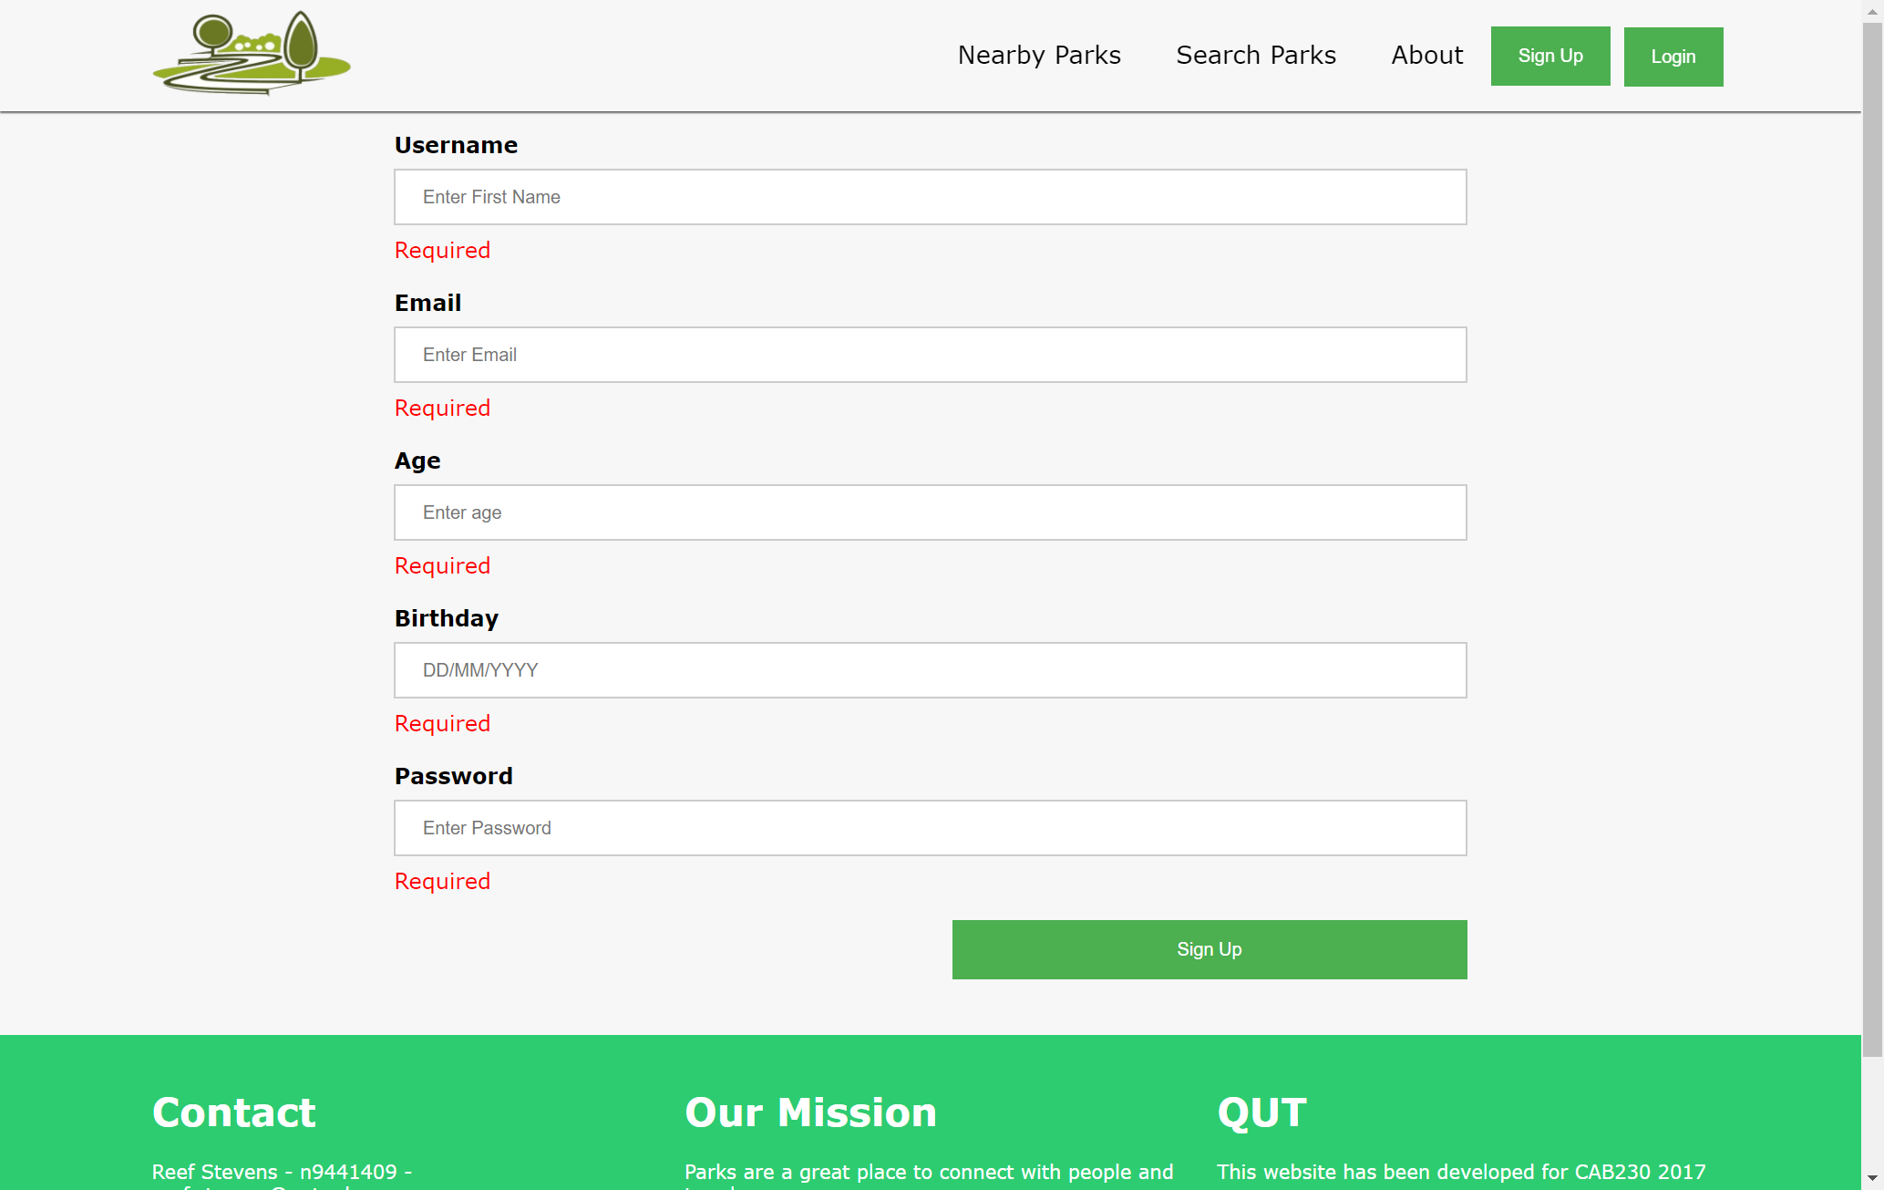

Red “*Warning”* notifications show as the user has clicked “*Sign Up”* without filling in *all* the required form elements.

## Correct input – Navigates to Login Page

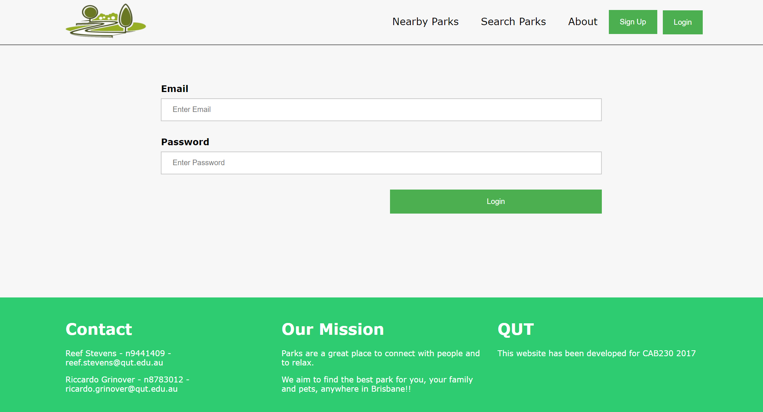

If signup form is submitted correctly and is validated both *client* and *server* side and all elements adhere to the set rules, the login page will show.

# Logging in as an existing user

## No INPUT - Have not clicked login



## No INPUT – Have clicked login

## Incorrect Input – Specific Warnings Shown

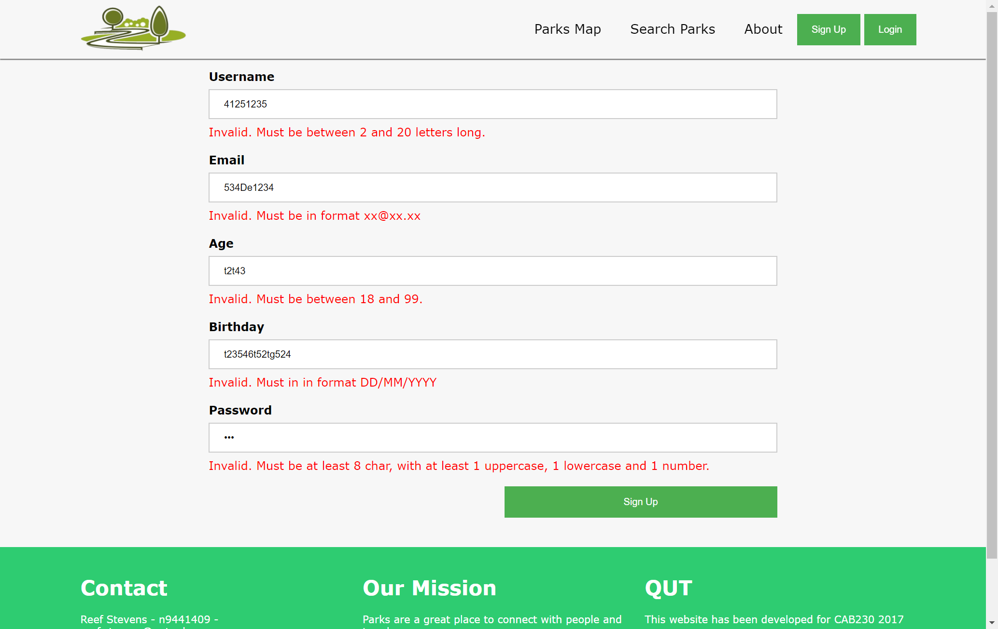

Red warnings display, notifying the user that their input was invalid. The warning messages also show the user the “*rules”* that apply to each form element so they know how to correct their error.

## Correct Input – Logged In!

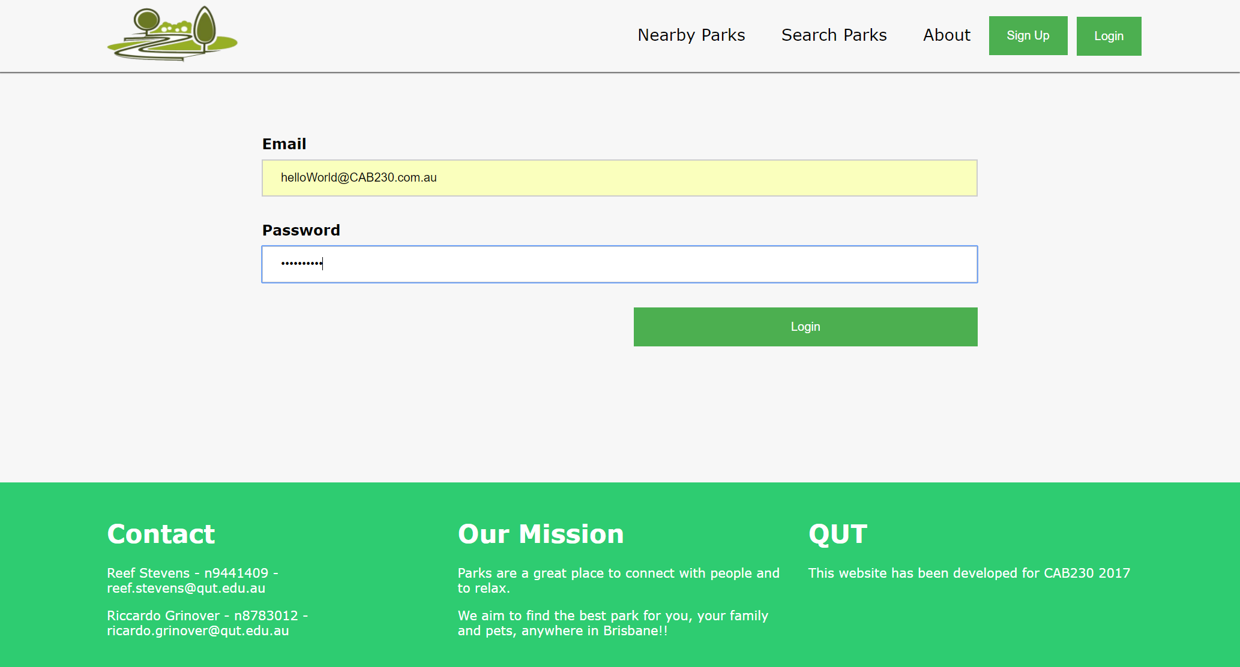

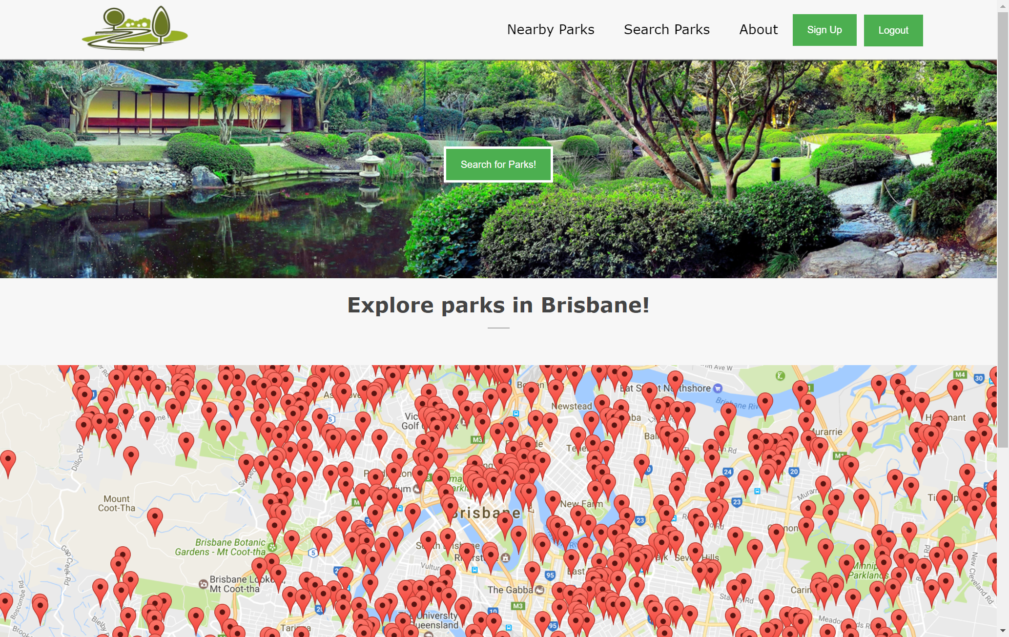

When you successfully log in, the website navigates the user back to the homepage. Note that the top right button in the header now indicates “*Logout”*, showing that the user is logged in successfully.

# Logging out

## User logged in



When the user clicks the logout button on the top right of the header, the website *removes the session data from the server* refreshes the homepage.

## User logged out

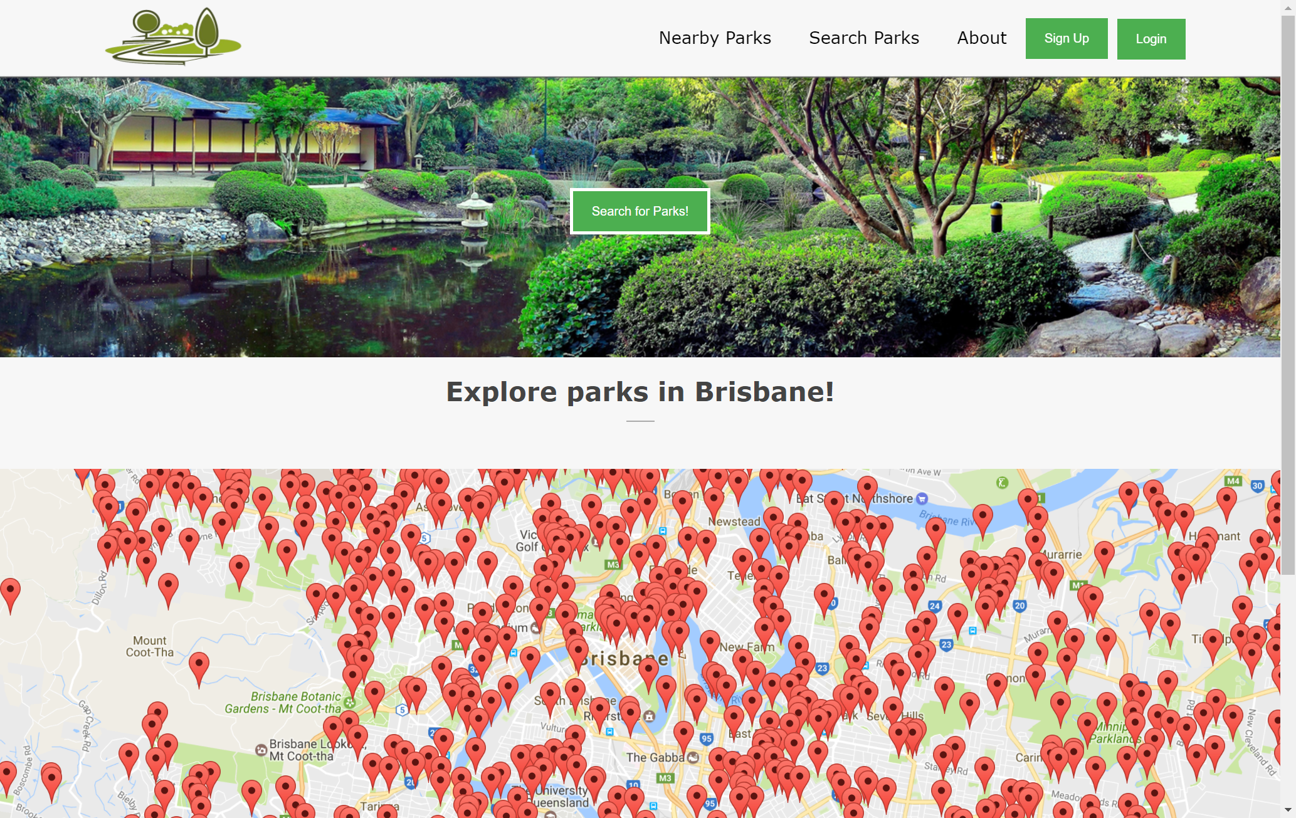

# Trying to log in with unregistered details

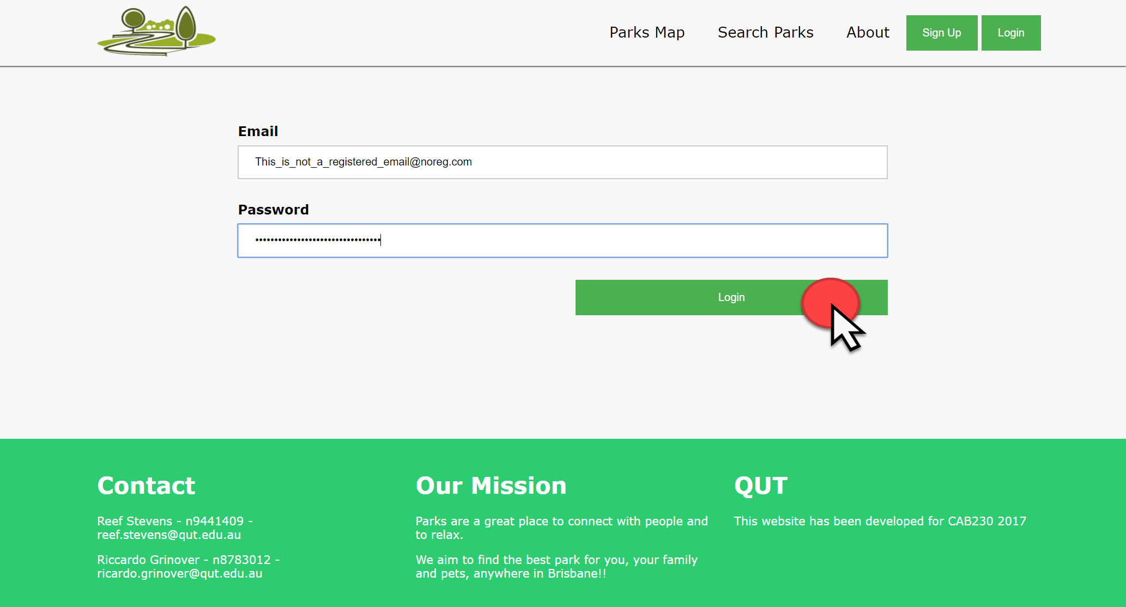

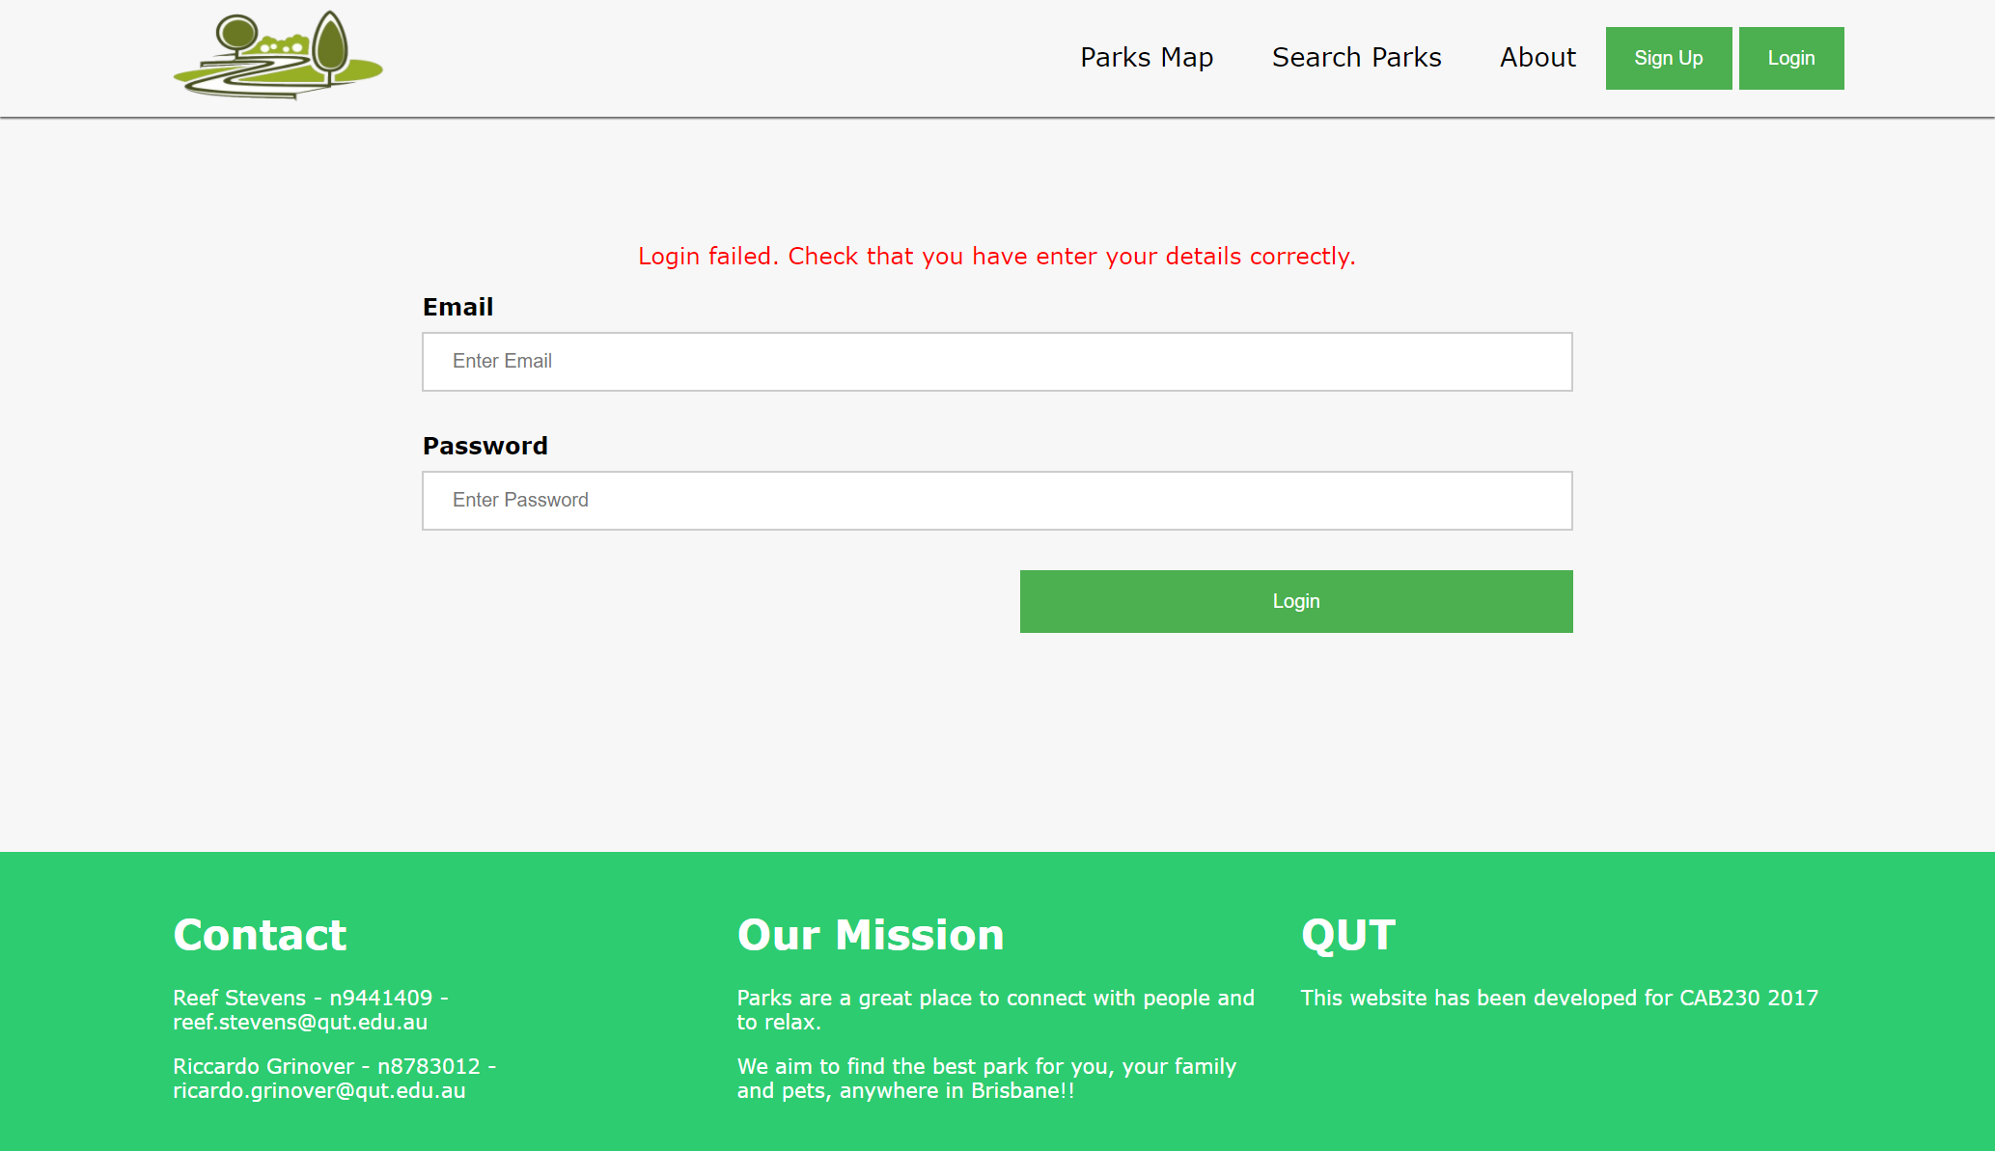

Here you can see that the unregistered user has not been able to log in. They are prompted with a message telling them to check their details. The message does *not* give away any information, It doesn’t tell them “That email is not registered”.

# Searching the database

## The search page

The search page allows to the user to search multiple the database with multiple criteria;

* Name

Searches the database by park name, returning the parks in a table.

* Suburb

When the user clicks the “Suburb” option in the dropdown menu, another dropdown menu appears. This dropdown menu contains all the suburbs (removing duplicates) that contain parks.

* Location

When the user clicks the “*Search by location”* button, the map zooms into the user’s location, which is displayed with a “jumping” map marker. The surrounding parks are shown on the map by markers as well.

The parks also show up in a table, like the “*Name”* and “*Suburb”* search options.

* Rating

When the user selects the search by rating option in the dropdown menu, a second dropdown menu appears that contains options 1 – 5. The user can select any of the options and click search. The search results are displayed in a similar table to the others. If the user searches for parks with a rating of “2”, the table would be populated with all of the parks that have been given a review of “2”.

The text search option “Name” is validated client side with HTML5 validation. Then a GET request is sent and the GET request parameters are validated server side. If there are no search results, the user is notified with a message.

## Searching for an item that exists in the database

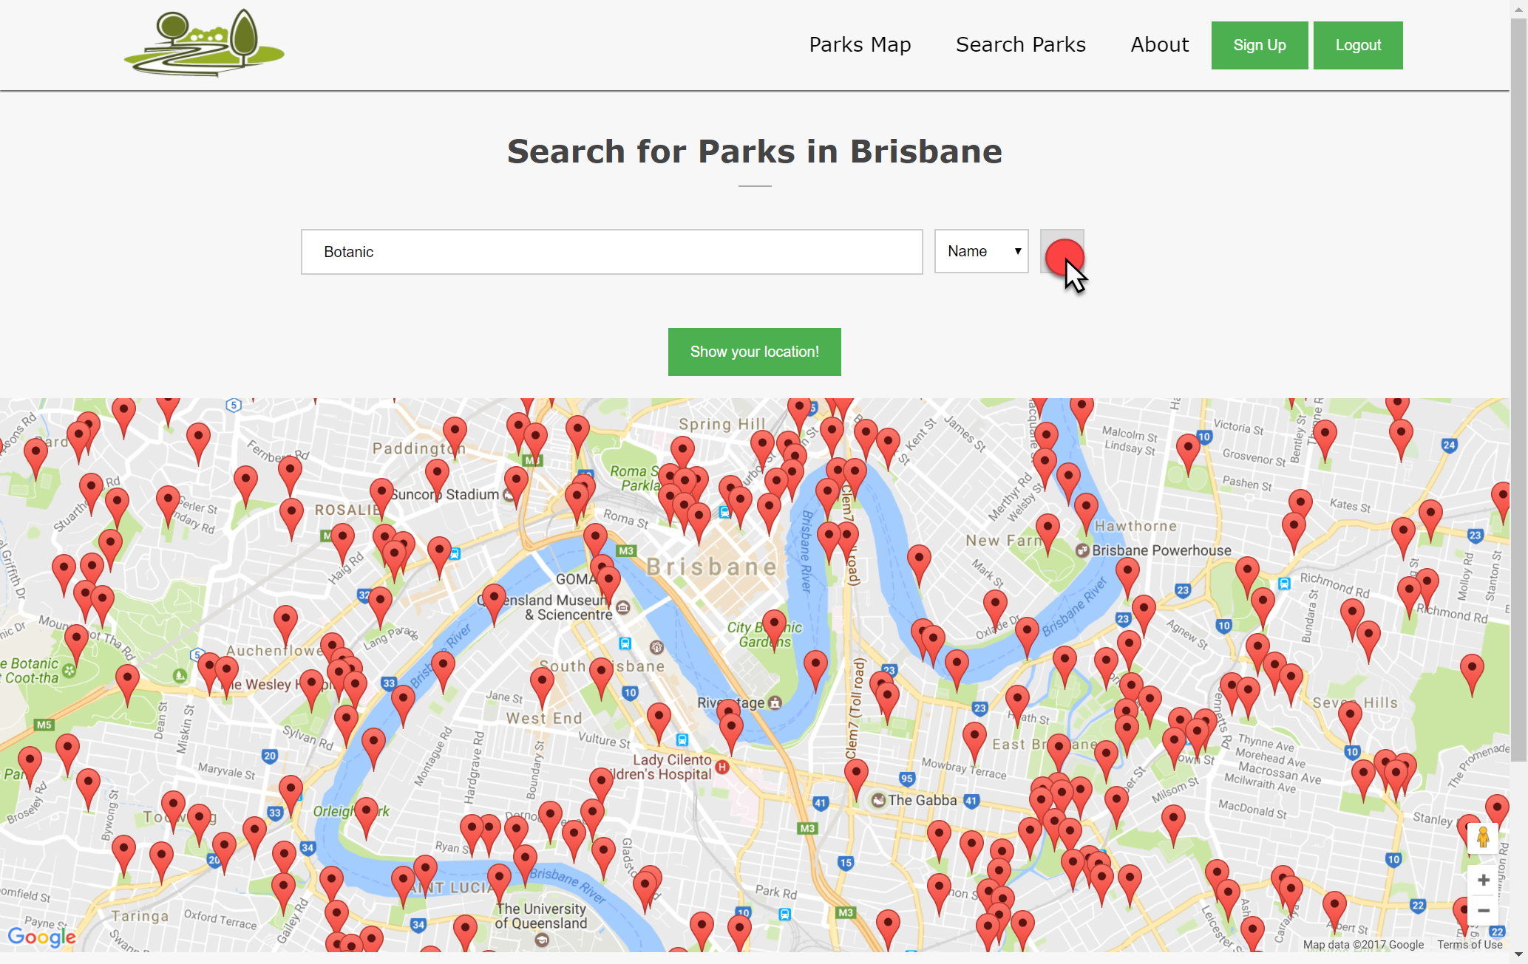

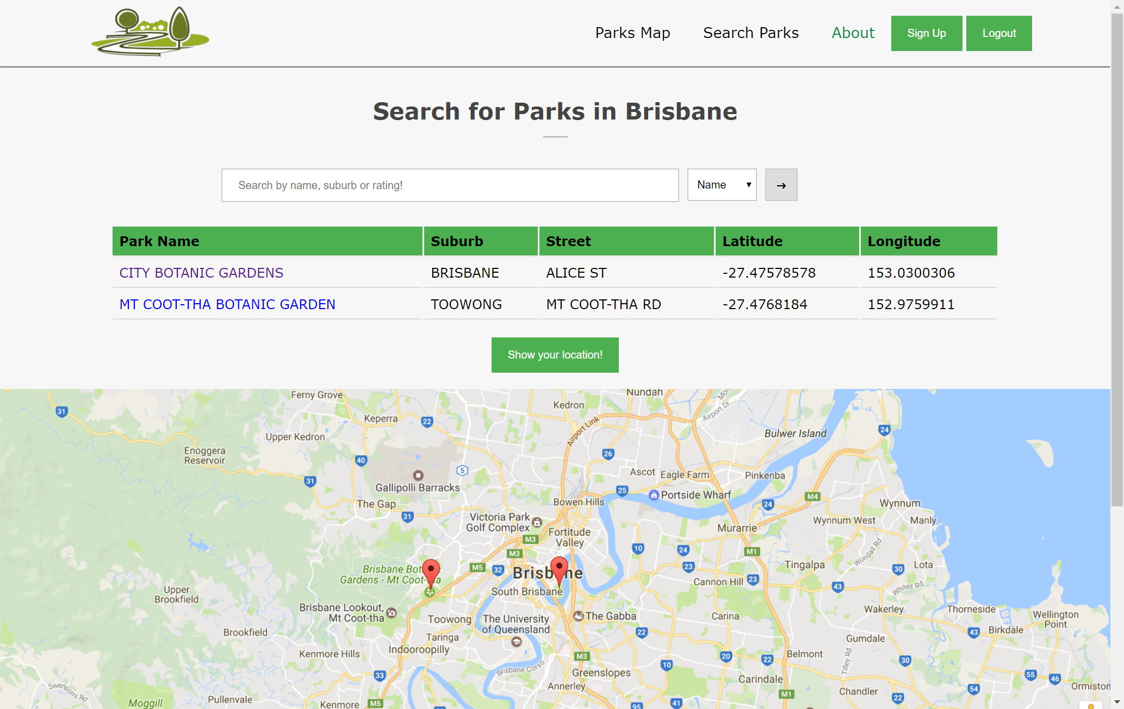

Before the user clicks the search button, all parks in the database are shown on the map. When the user clicks the search button, the results are shown in a table and the map refreshes – now only showing the parks displayed in the table.

## Searching for an item that doesn’t exist in the database

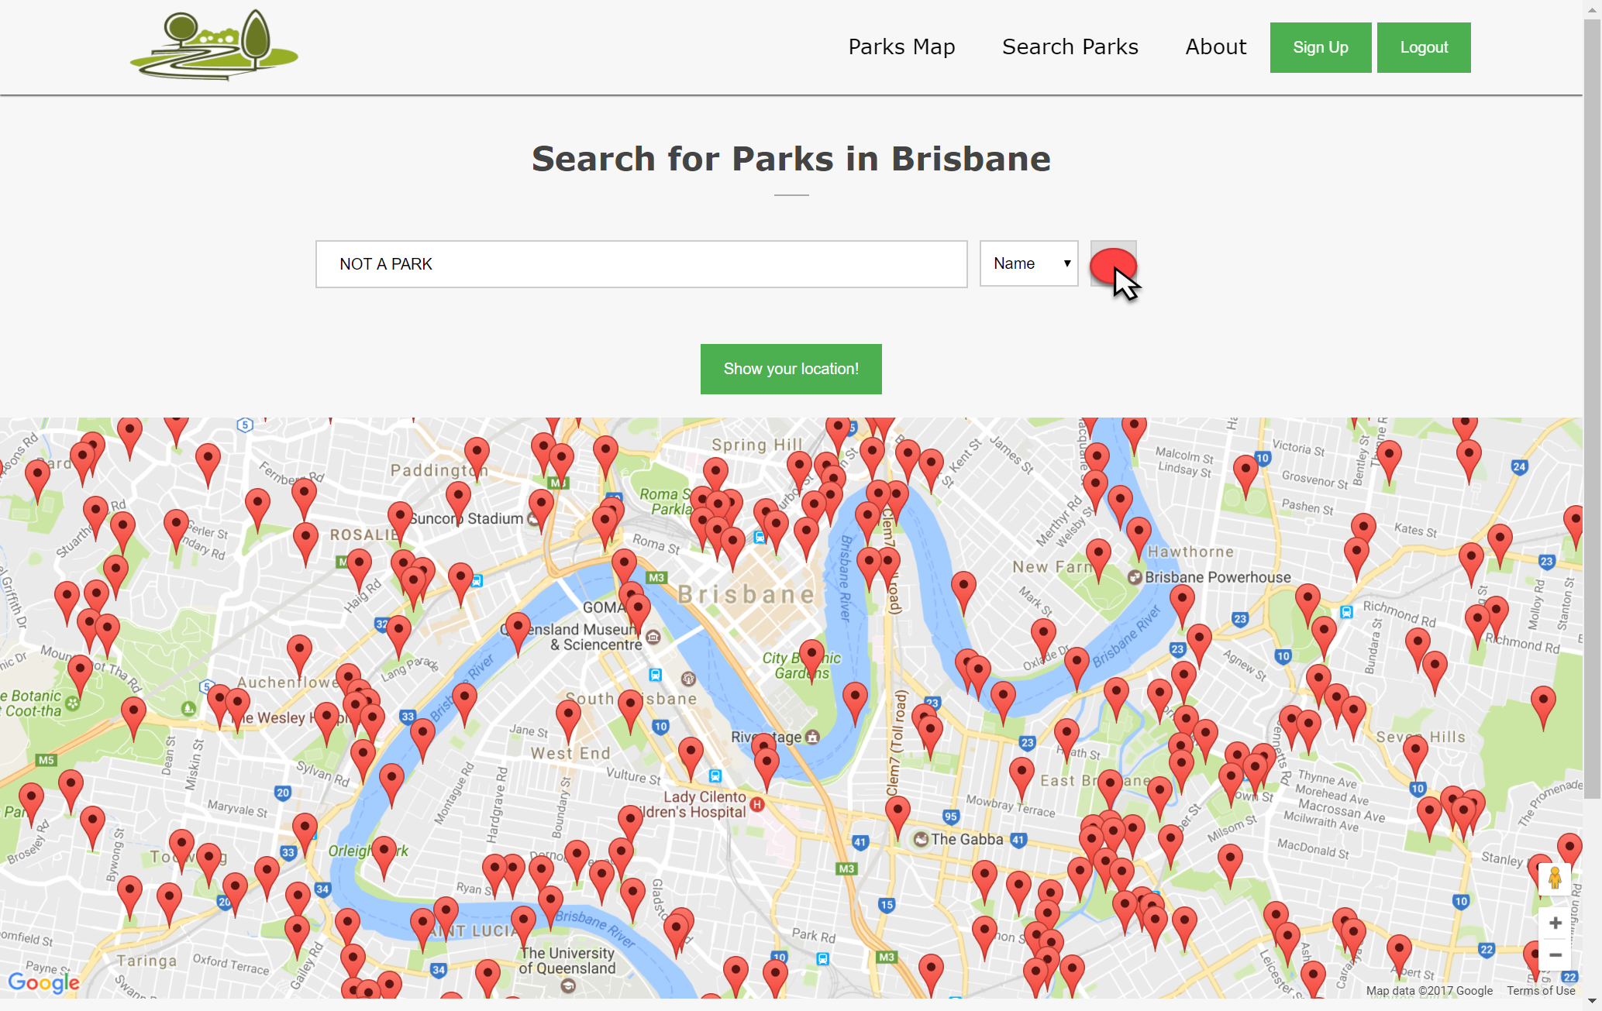

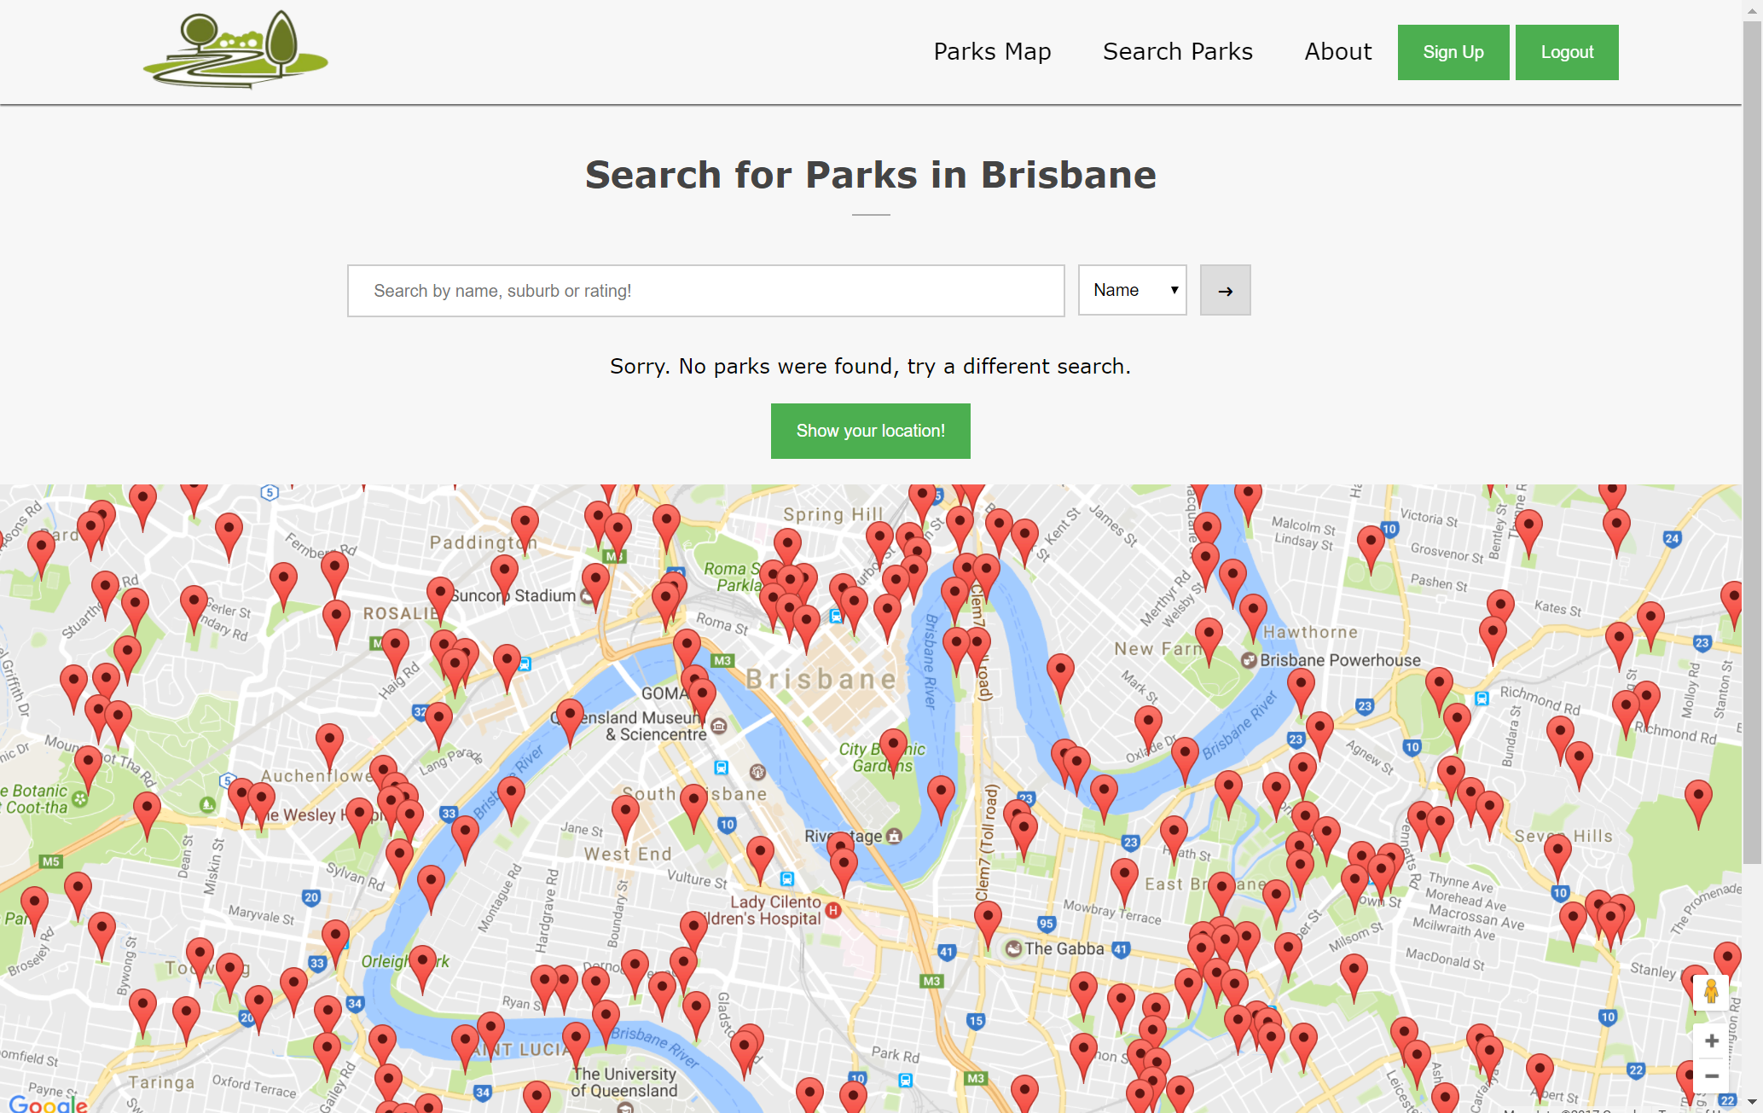

When the user searches for the name of a park that does not exist in the database, they are prompted with a message telling them “Sorry. No parks were found, try a different search”. All parks are displayed on the map.

# Accessing an individual item page

When the user clicks an individual park from the display table, the website opens an individual park page that shows the park located on a map, as well as all the parks basic information such as park name, street and suburb.

# Adding a review

# Attempting to use a cross site scripting attack but not being successful

# Attempting to use an SQL injection attack but not being successful

# Handling multiple resolutions

## Home page – Standard resolution



As expected, the website functions well with a standard – large resolution.

## Home Page – Small Resolution

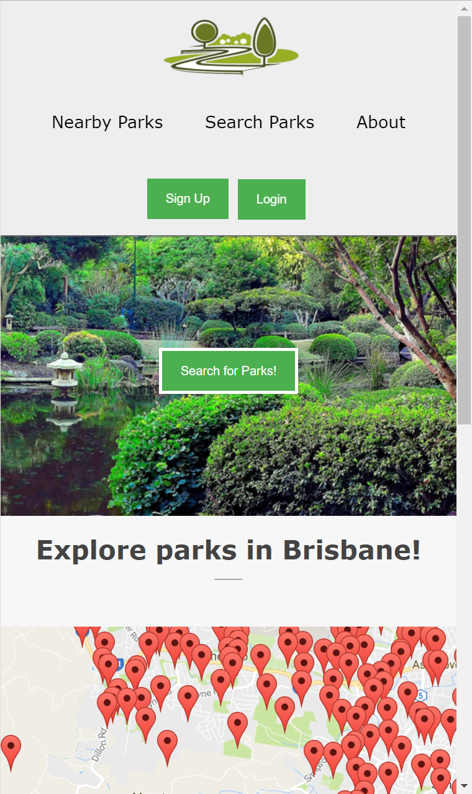

The website also works at a very small resolution as well, which is essential for mobile users.

# Adding login information to the database

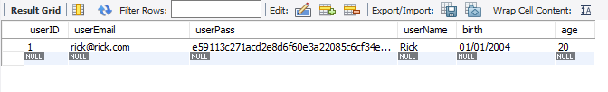

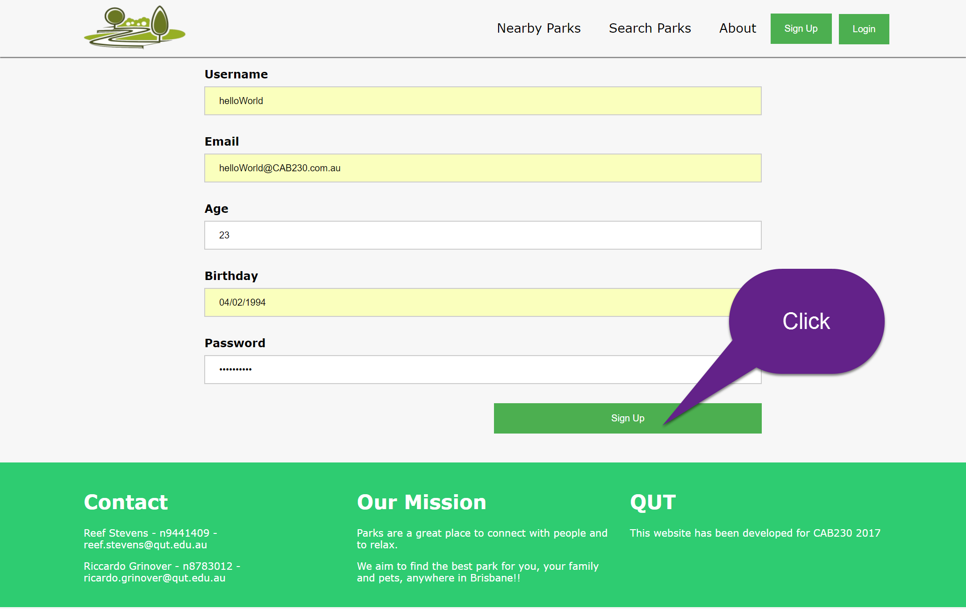

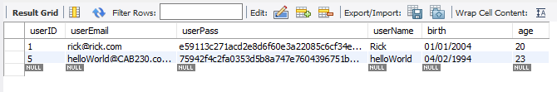

# Evidence that the geographic microdata is valid as reported by Google’s structured data validator (Add on #2)

# Evidence that the microdata is valid as reported by Google’s structured data validator (Add on #2)

# Design Principles

## C:\Users\Godzi\Desktop\honeycomb.jpgUser Experience

For a positive user experience to be achieved, the provided information must be;

* Useful

The created Brisbane parks search is useful as it is the solution to a problem the user has – Not being able to locate parks around their local area.

* Usable

The website is user friendly, having a basic easy to follow design where all the main components of the website can be accessed from the homepage.

* Desirable

The colour scheme used on the website evokes positive emotions from the user, as the scheme consists of bright “*happy*” colours.

* Accessible

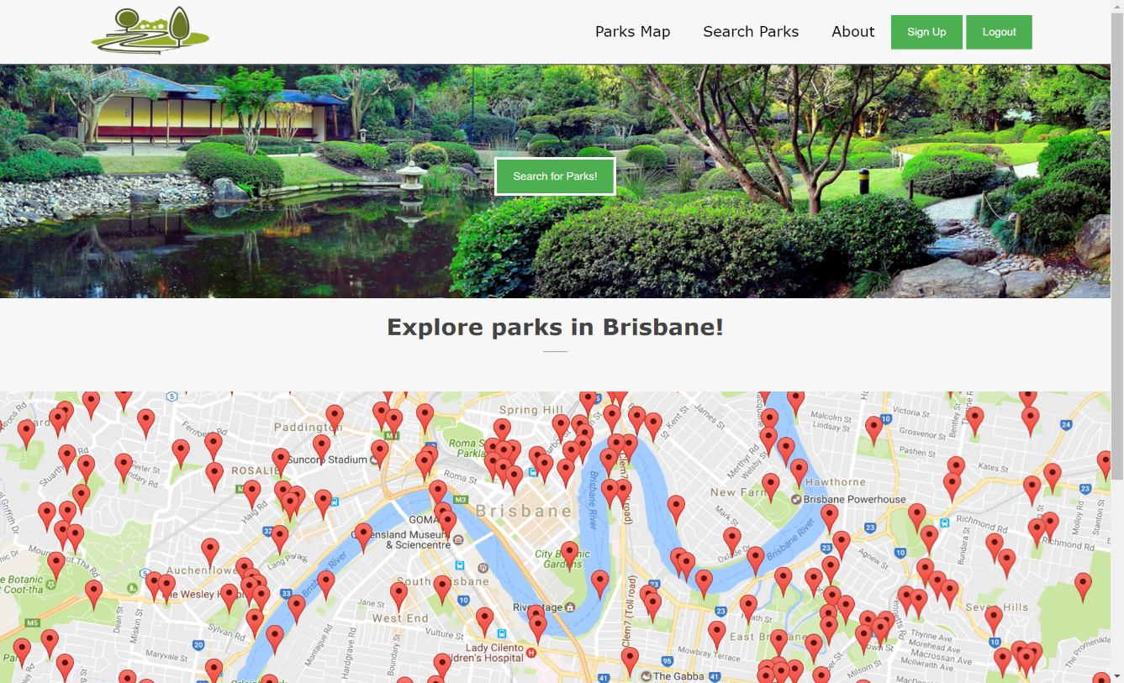The website is accessible to people with disabilities as each page has a description in the metadata – allowing for assistive technologies to help describe what is on the page.

## Visual Design & Page Layout

The visual design and overall page layout of a website is very important. If a website looks unappealing or is structured in a manner that is not easy to use of navigate through, a user will find an alternative website.

A simple and visually appealing page layout is critical for the site to be used efficiently. The key idea is for all the main features of the website to be located close to each other, so that minimal effort is needed when switching between webpages. The page layout must help direct the user as to what they should do next, which is demonstrated in the screenshot of our parks website below as the central button that has the websites key functionality is located within the centre of the screen.

The functions of all buttons and labels must be clean and concise and must accurately convey what they do. All the buttons in the parks search website as simple and descriptive. A consistent layout across all webpages is important when creating a website as this increases the aesthetic appeal and the ability of users to efficiently navigate through the website.

### Visual Hierarchy

The website utilises *visual hierarchy* to draw the user’s attention to important components of the website first.

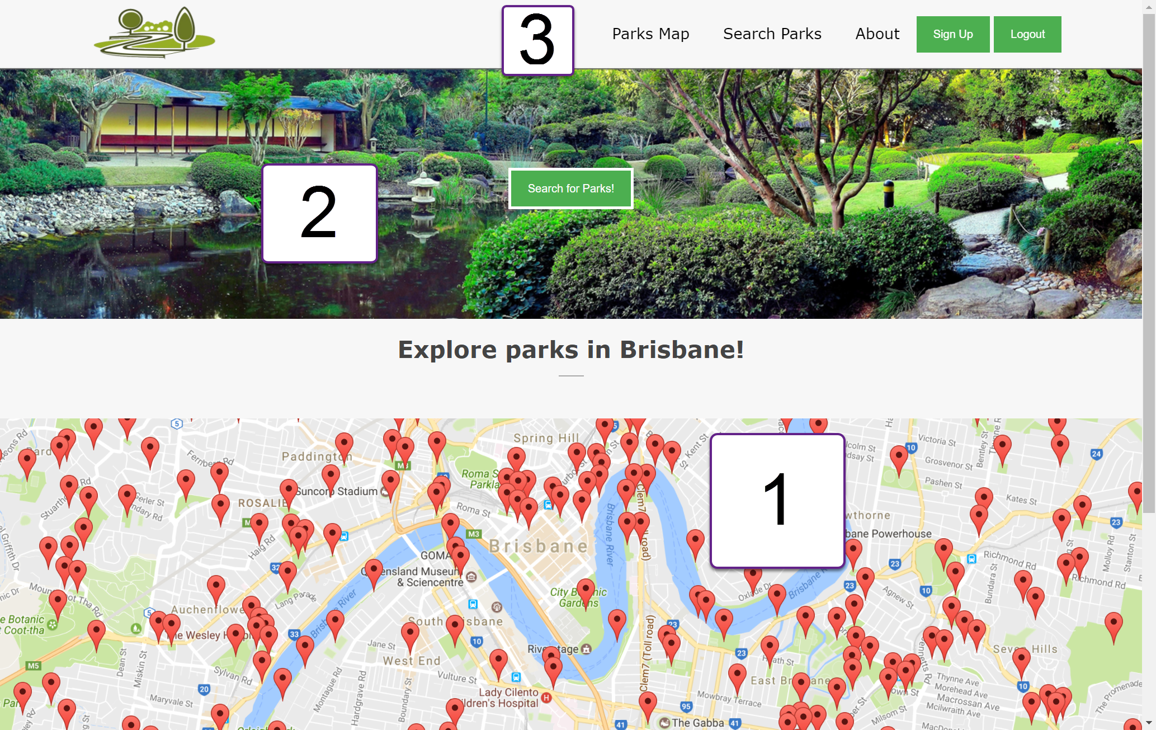

The user’s gaze is initially drawn to the map because of its large size and mass of red highlights. The map was chosen as the first thing the user see’s because it can be interacted with straight away. This is very important as a user will generally know if they want to use the site within the first few seconds of seeing/interacting with it. The users gaze is then drawn towards the large park picture with the centrally located search button. Finally, the user looks at the header where they have majority of the options to choose from.

### Golden Ratio

The website roughly follows the golden ratio of 1.618 / Fibonacci sequence, which is thought to produce an aesthetically pleasing.

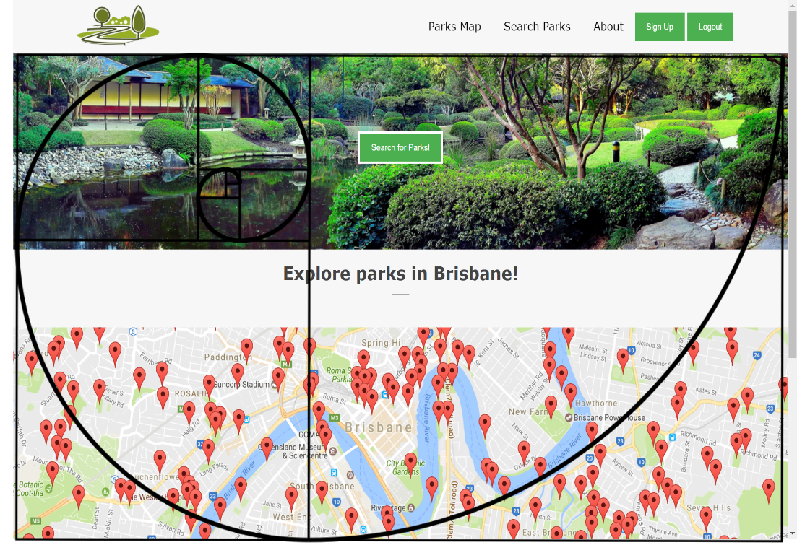

### Fitts Law

Fitts law is based around have buttons / features that are most commonly used put into easy to access places on your website. This was taken into consideration when placing key button on the parks website, such as the login, signup and search buttons. These key buttons are also highlighted a different colour to help them stand out even further.

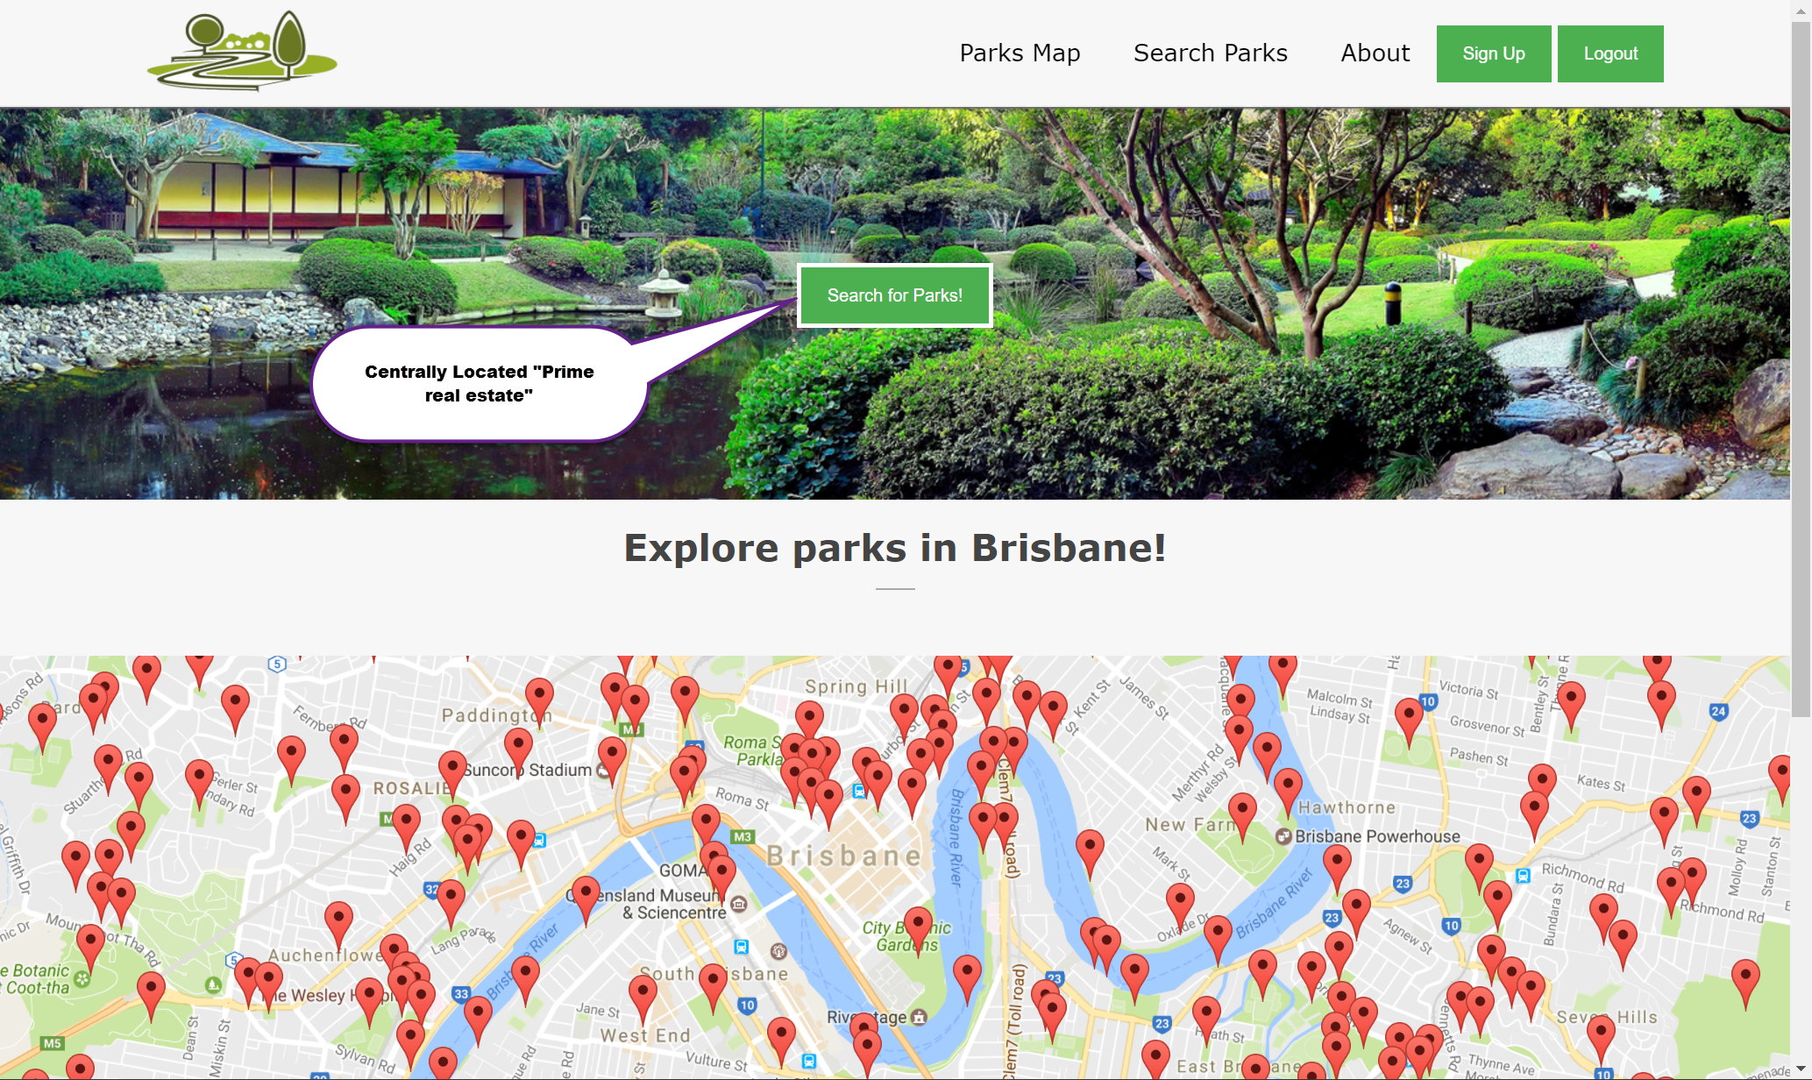

## Standards

The created park search website complies with all taught standards where possible. Each page passed a HTML5 validator: <https://html5.validator.nu/>​ and our CSS style sheet validated with no errors as well, the CSS validator used is located at: <https://jigsaw.w3.org/css-validator/>. The site works correctly with large and small resolutions, allowing for use across multiple devices from desktop computers to smart phones. The website conforms to appropriate Accessibility standards where possible, such as providing descriptions for photos and certain aspects of the webpage allowing for alternative viewing of the website.